* **Task 2: Cloudera**
* Task 1: Access UMKC cloudera servers

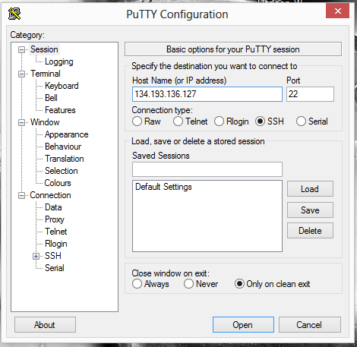

* Task 2.1: How to install your own cloudera server

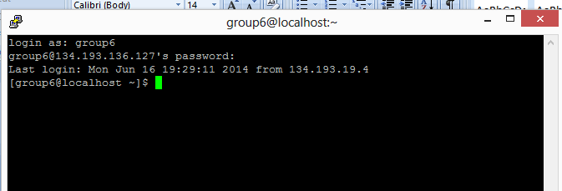

* Task 2.3 How to transfer files to cloudera{**using Winscp**}

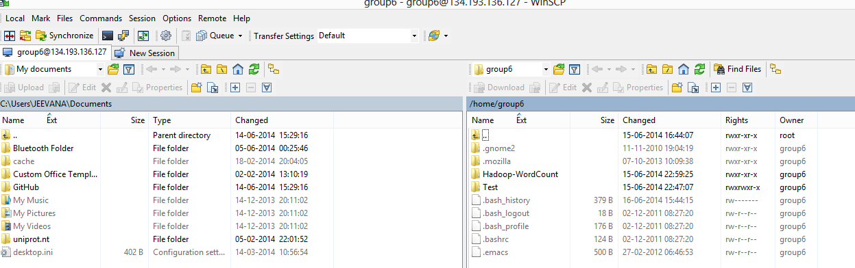

* Task 2.4 Run word count on cloudera

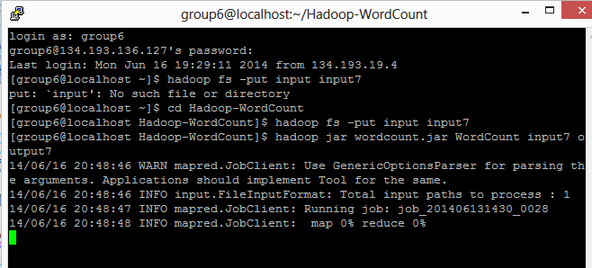

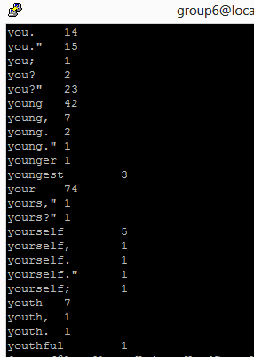

Sample output